**Assignement 8**

To create a snapshot go to the instances page and click on the Instance ID

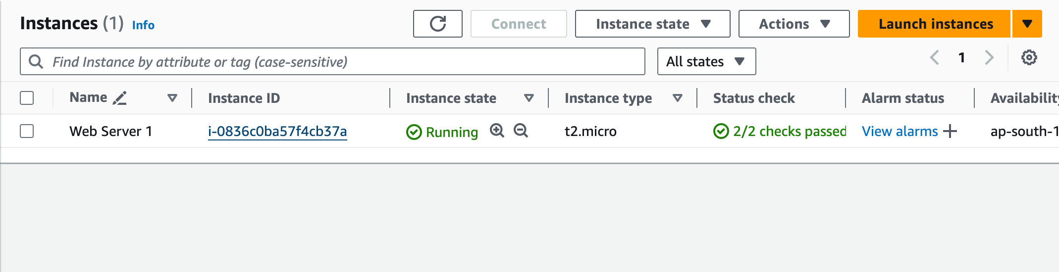

Scroll down, under storage click on volume ID

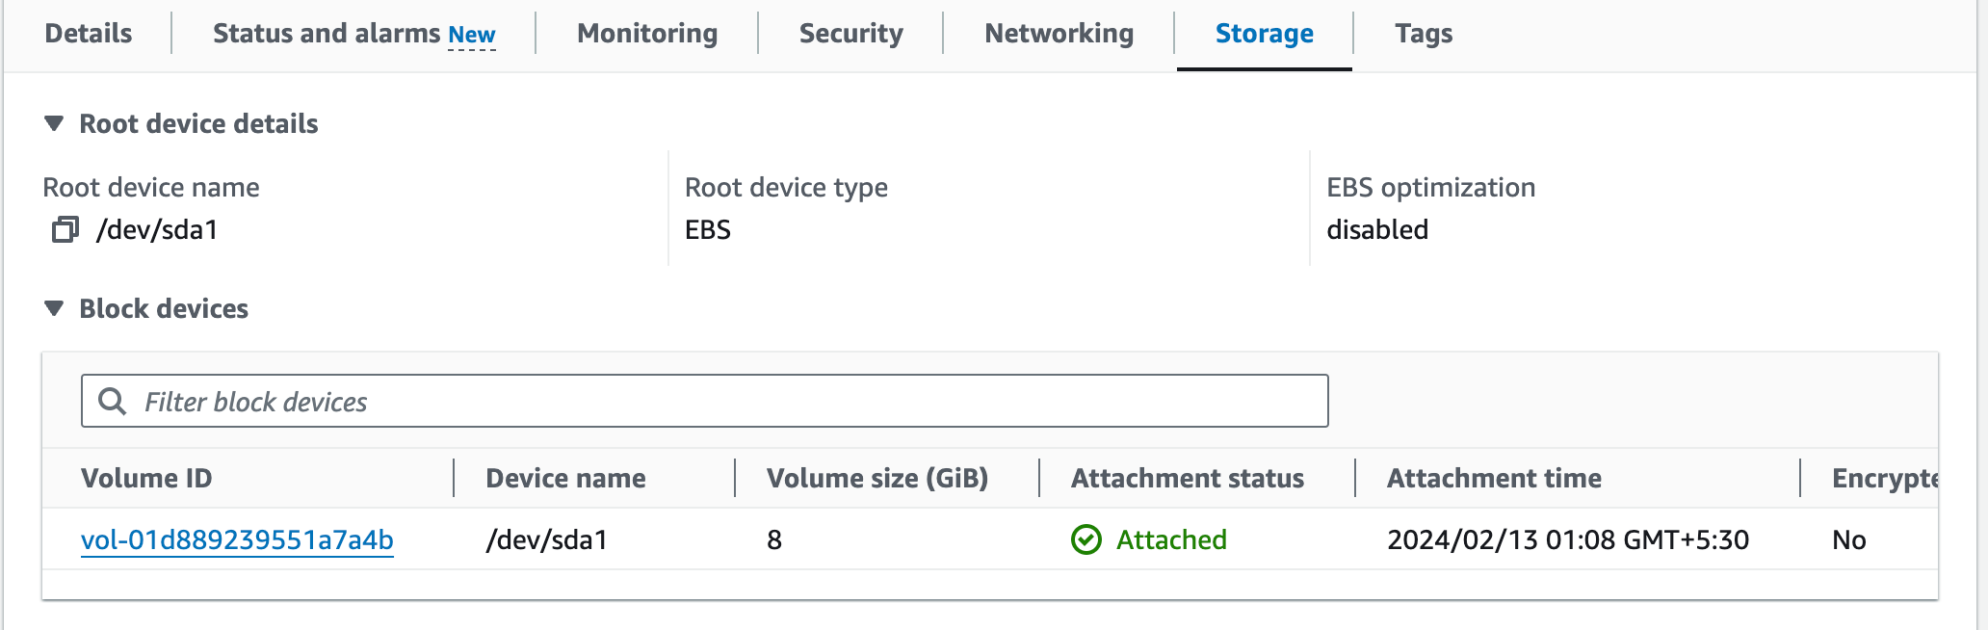

Again click on volume ID

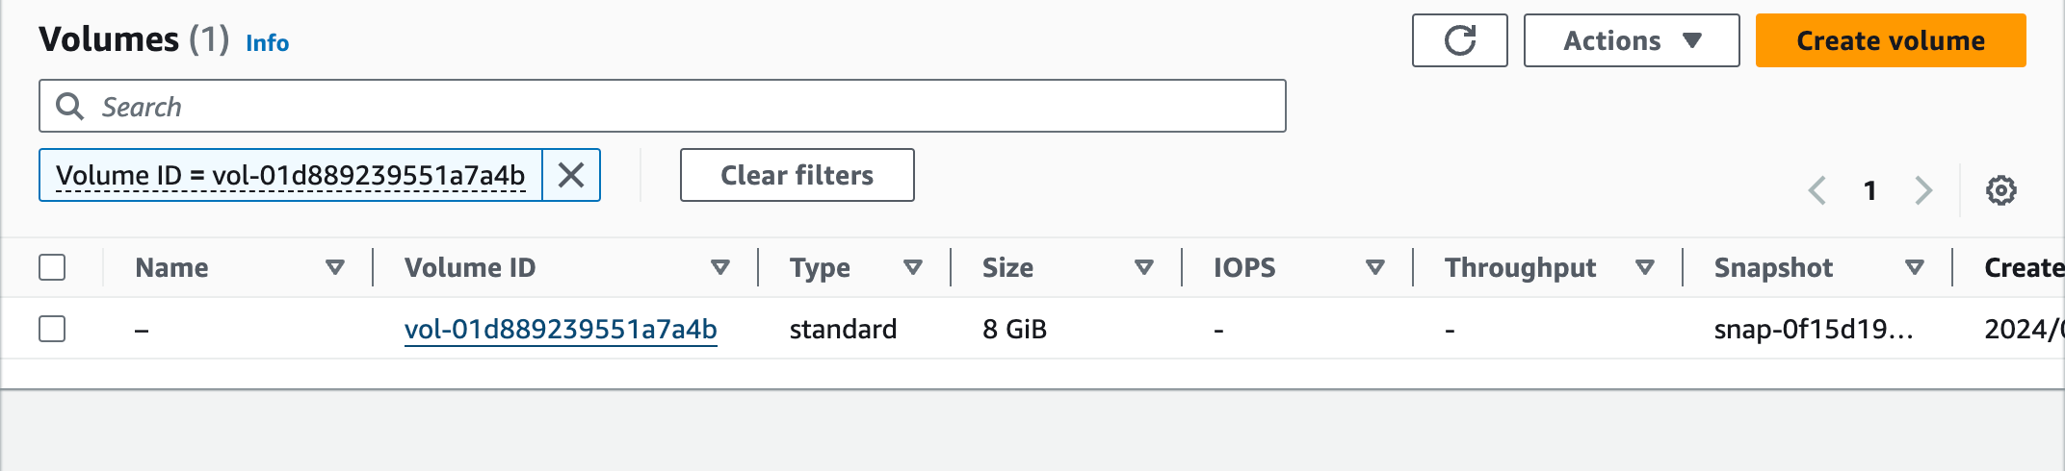

In the actions dropdown click on create snapshot

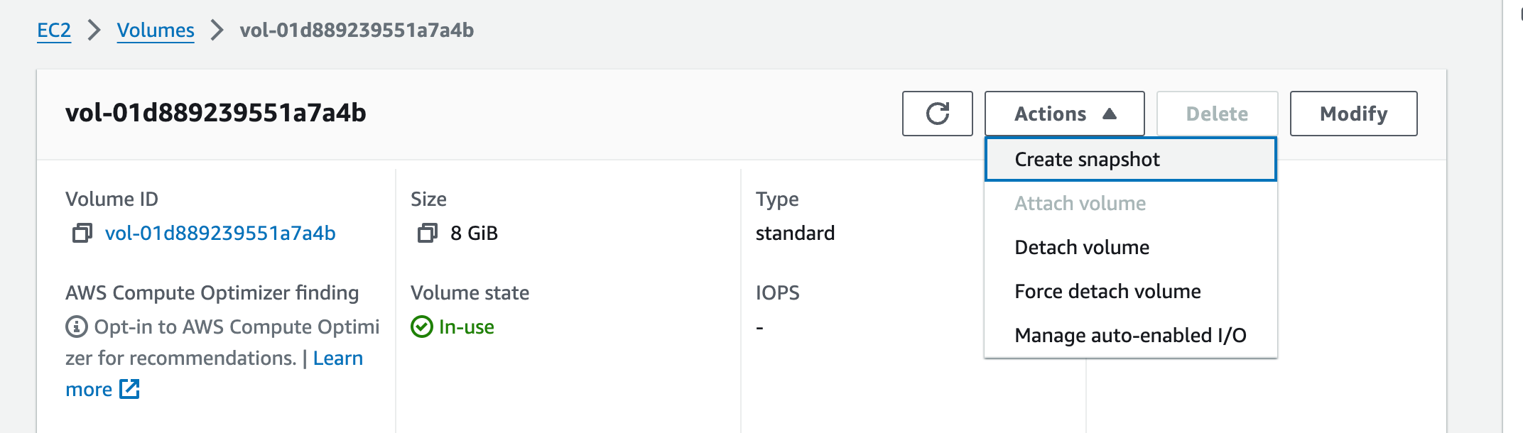

Give a snapshot description, then scroll down and click Create Snapshot

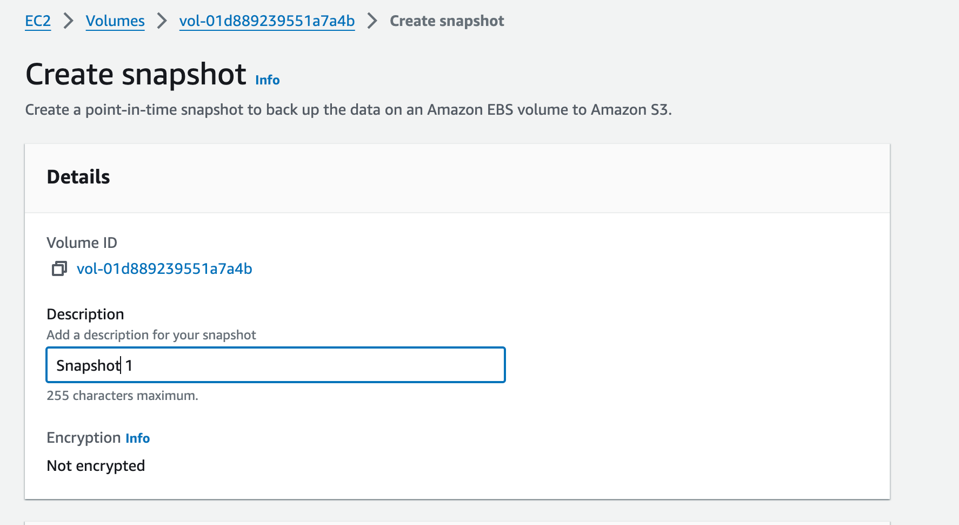

A confirmation will show the successfull creation of snapshot



Go to the snapshot page to see the snapshots

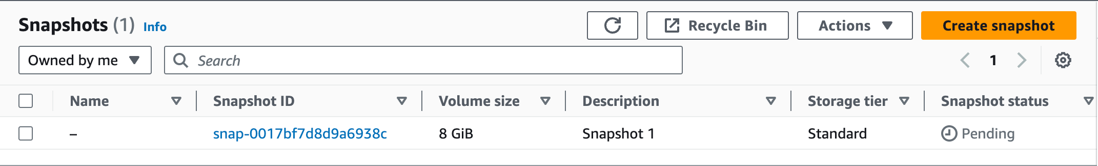

Now to create an Amazon Machine Image from the snapshot, select the snapshot and from the actions dropdown click on Create Image from Snapshot

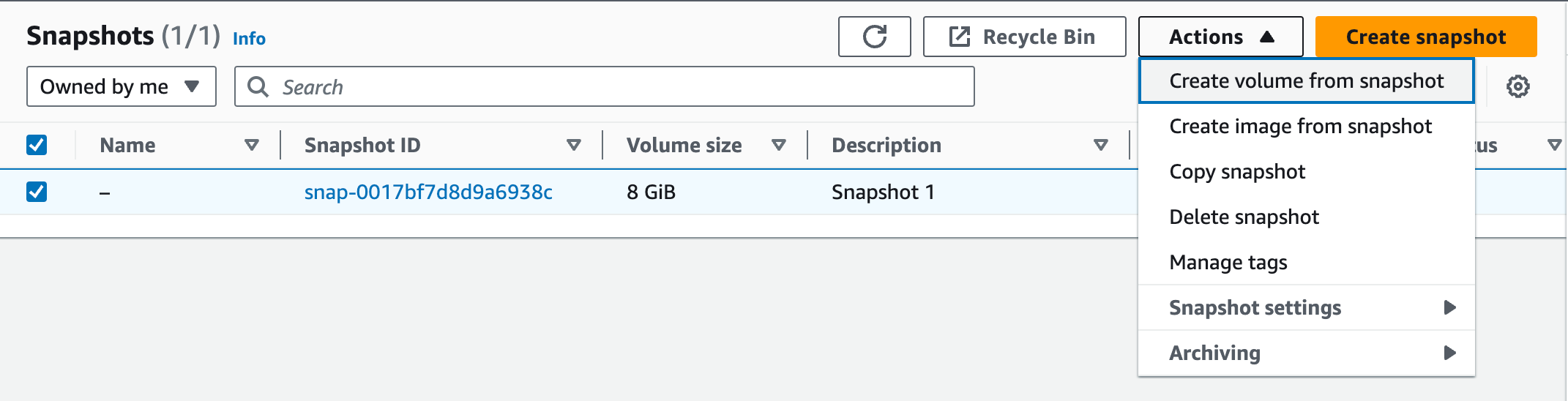

Give a name and description and scroll down and click on Create Image

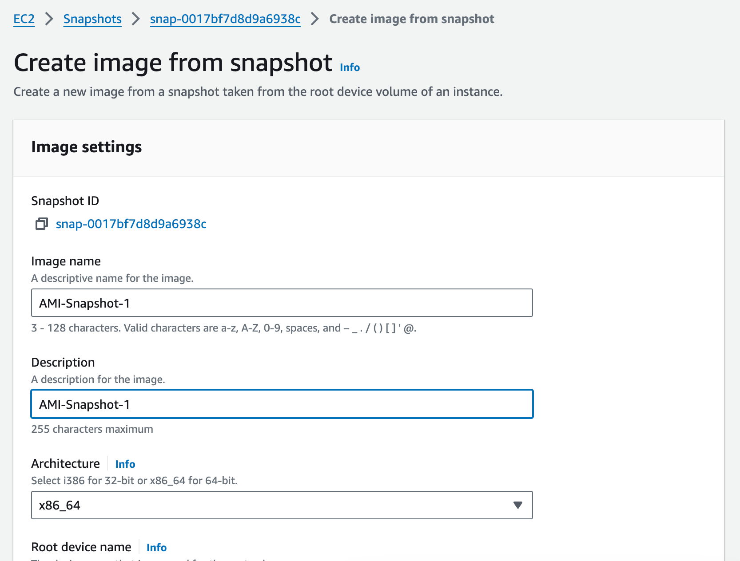

Then go to AMIs to see the images

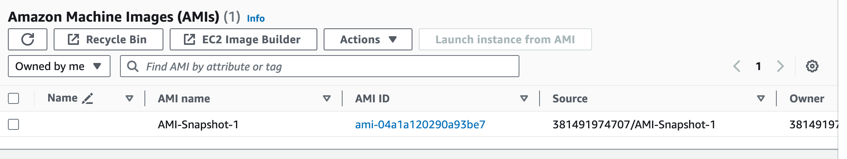

To launch an instance using this image select the image and click on Launch Instance from AMI from the top

Now give a name and select the necessory things like keypair, security group etc.

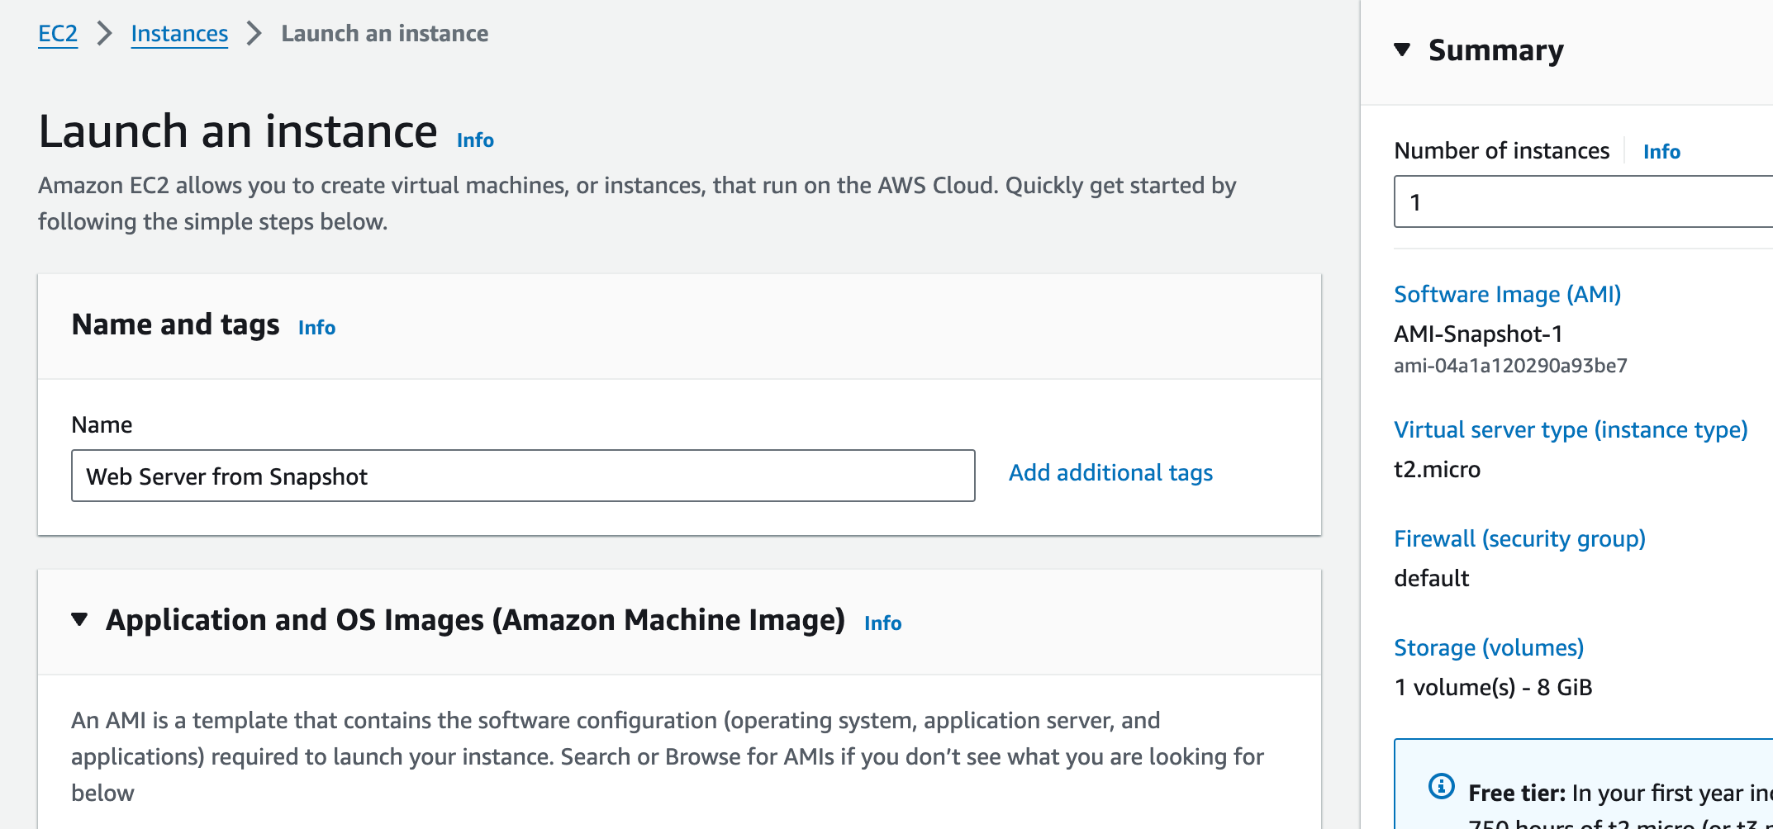

To launch the instance click on Launch Instance

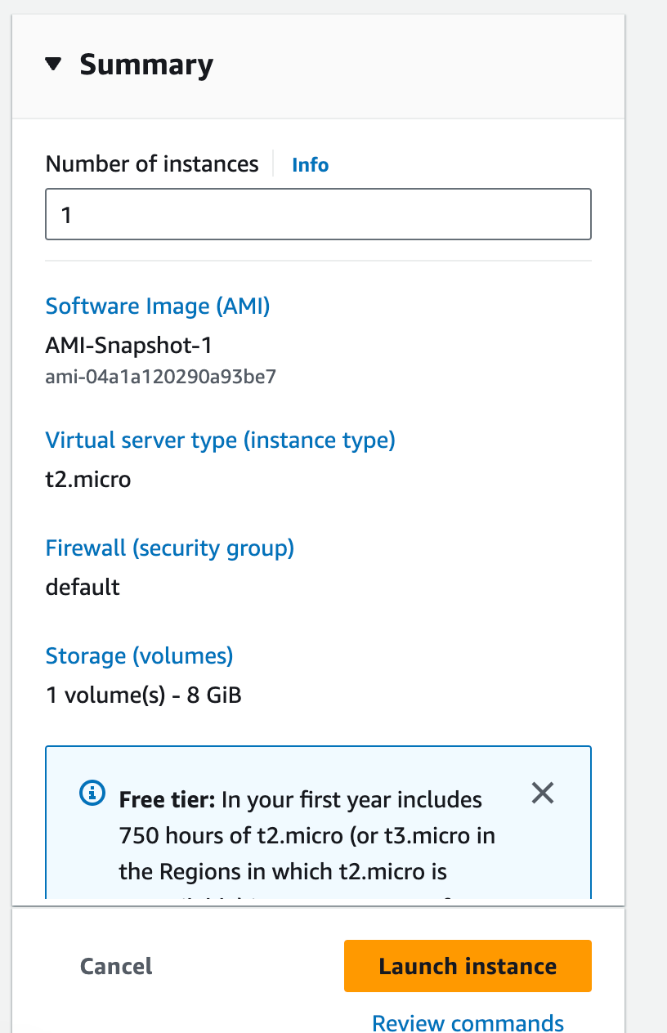

Now we have successfully launched an instance

